ENGLISH WORKSHEET 6° GRADE
NAME:
GRADE: |  | DATE:
OBJETIVO(S): Leer comprensivamente texto relacionado a comidas.

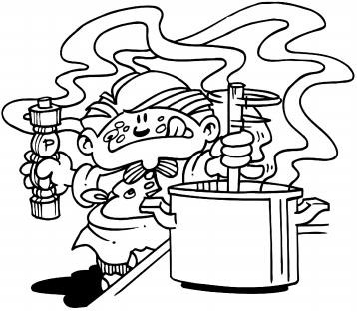
1.- Read the following texts carefully.
Eating out
The British have “imported” food from very different cultures, e.g. the Indian, the Chinese and the Italian.One reason for the popularity of these types of restaurant is that they are often much cheaper than the more traditional British ones which serve a mixture of British and French cooking. In the larger cities there is a great choice of restaurants. Good examples of this are the vegetarian restaurants which offer a different type of food.

Take-away food
Restaurants often have a take-away service in which you buy the food cooked and take it to eat elsewhere. The most common are Indian, Chinese and Italian pizza take-aways and there are also the American fast-food restaurants. The original British take-away food is fried fish and chips (fried potatoes) and there are still hundreds of fish and chip shops.

Self-service
Another cheap way to eat out is to go to a self-service cafe where you serve yourself from a counter and pay for your food before eating it.
Many self-service restaurants now offer a good range of salads and hot meals.

Restaurants
Restaurants are usually more expensive than fast-food restaurants or self-service cafes. Most restaurants show a menu outside the building so you can see the type of food served and the prices. Drinks such as wine and beer usually cost more in a restaurant than in a shop or pub.

A. Are these statements true (T) or false (F)?
1. ________Traditional restaurants are more popular than Indian, Chinese or Italian restaurants.
2. ________People save money if they go often to these types of restaurant.
3. ________When you go to a take-away restaurant you buy the food you want to eat and then you sit at the counter and enjoy your meal.
4. ________In a self-service cafe things are more expensive because there is a waiter.
5. ________You don’t have to go inside a restaurant to see what they are serving.

B. Answer the following questions.
1. Why are fast-food restaurants so popular in Great Britain?
____________________________________________________________________________________________________________________________________________________________________________________________.

2. What sort of food can you buy in a take-away restaurant? Give examples.
____________________________________________________________________________________________________________________________________________________________________________________________.

3. What are the main differences between a self-service restaurant and a traditional restaurant?
____________________________________________________________________________________________________________________________________________________________________________________________.

4. What type of food do you like the most? And what drinks?
____________________________________________________________________________________________________________________________________________________________________________________________.

