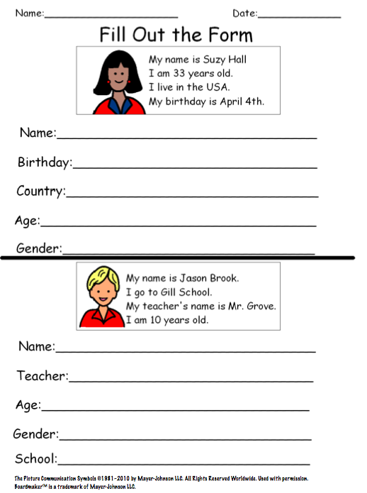
ENGLISH WORKSHEET 5° GRADE
NAME:
GRADE: |  |  | DATE:
OBJETIVO(S): Comprender y completar informacion personal .

