ENGLISH WORKSHEET 3° GRADE
NAME:
GRADE: |  |  | DATE:
OBJETIVO(S): Aprender e identificar la ropa en inglés.

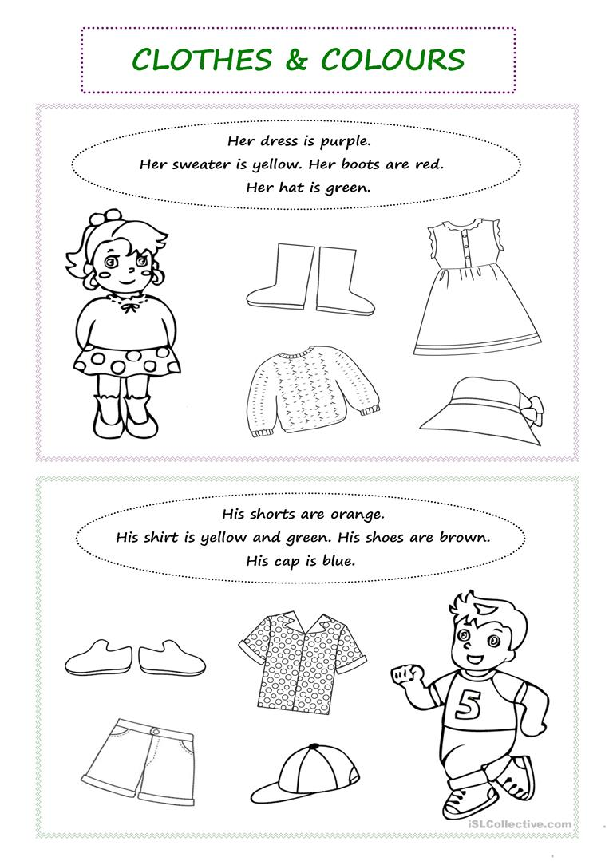
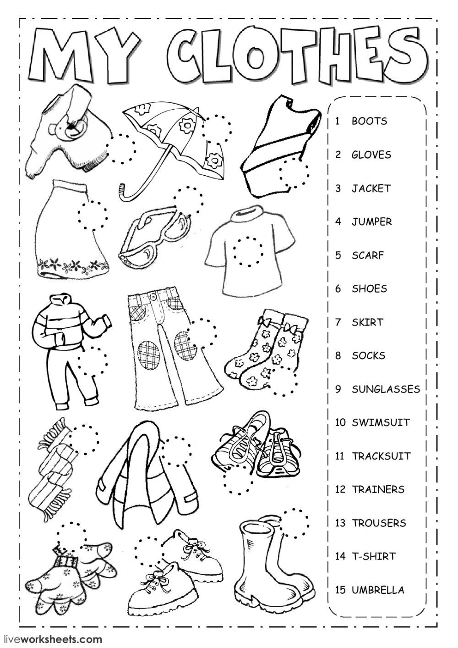

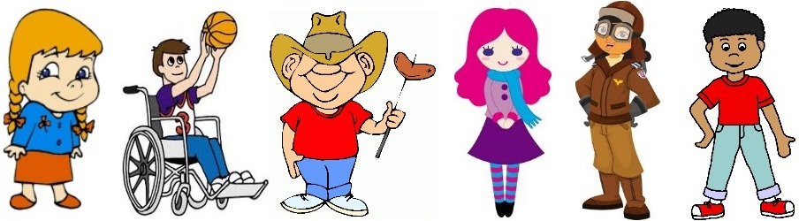

_________ __________ ___________ _________ _________ __________

Grace is wearing a purple skirt and a pink blouse with black buttons. She is also wearing black shoes and a blue scarf.
Henry is wearing a white and purple T-shirt with number three on it, blue trousers and white trainers. He likes playing basketball.
Jenny is wearing a brown jacket, brown trousers and a brown hat. She is also wearing brown boots and glasses. She is a pilot.
Alice is wearing a blue shirt with a red flower on it, an orange skirt and orange shoes. She has got long hair and big eyes.
Mark is wearing a red T-shirt, blue jeans and light blue trainers. On his head he is wearing a brown hat. Mark is eating a sausage.
George is wearing a red T-shirt, blue jeans and white socks. He is also wearing red and white trainers. George is happy today.

