**ENGLISH WORKSHEET 1° GRADE**

|  |  |  |  |  |
| --- | --- | --- | --- | --- |
| NAME: |  | | | |
| GRADE: | |  | DATE: |  |
| OBJETIVO(S): Identificar útiles escolares y colores en inglés. | | | | |

**I TRACE THE SCHOOL SUPPLIES. (Traza las palabras de los útiles escolares)**

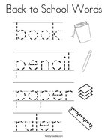

**II READ AND COLOR THE SCHOOL SUPPLIES. (Lee y colorea con los útiles escolares con el color mencionado)**

